Physics 30 Lesson 7

Optics – Curved Mirrors

Refer to Pearson pages 656 to 665.

# Plane Mirrors – Revisited

In our previous work on *Reflection*, we saw that for plane mirrors the image of an object always exists *within* the mirror – we can never touch or project the image since it *does not exist as something outside of the mirror*. Images which exist “inside” the mirror are referred to as *virtual images*. Images that can be projected onto a screen outside of the mirror are referred to as *real images*. (A quick example of a real image is the image made by an overhead projector. The image of the transparency is easily projected onto a screen.)

virtual image

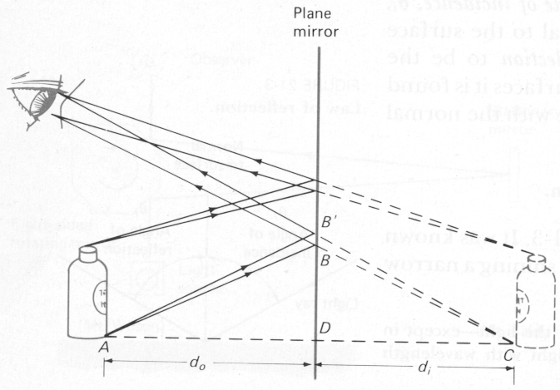

# Spherical Mirrors

Spherical mirrors, like plane mirrors, obey the law of reflection (i = r), but for spherical mirrors the ***normal*** *is always the radius of the sphere*. Spherical mirrors come in two types: ***converging*** (concave) and ***diverging*** (convex). For a ***Converging*** or ***Concave*** mirror, light rays reflect toward the focal point.

Incident ray

•

•

Reflected ray

Normal

centre of curvature

focal point

principal axis

The *principal axis* is an imaginary line that extends outward from the centre of the mirror.

For a converging mirror, incident light rays which are parallel to the principal axis are reflected toward a real focal point.

For a ***Diverging*** or ***Convex*** mirror, light rays reflect away from the focal point.

Incident ray

•

•

Reflected ray

Normal

centre of curvature

focal point

(virtual)

principal axis

For a diverging mirror, incident light rays which are parallel to the principal axis are reflected away from a virtual focal point.

The terms “real” and “virtual” are used to refer to where objects and their images are in space. A real image exists in actual space where we can touch the image with our finger. A virtual image, on the other hand, exists only within the mirror. For example, your image in a plane mirror is a virtual image since you cannot actually touch the image. A virtual image exists solely “within” the mirror.

# Image formation – spherical mirrors

*Ray diagrams*

There are literally billions of light rays striking a mirror from an object such as a light bulb.

•

•

r

f

do

di

Object

Image

Fortunately, in order to determine if an image is formed it is not necessary to draw hundreds of rays reflecting off of a mirror. In fact, there are three very useful rays which may be used to determine the position, orientation and nature of an image being 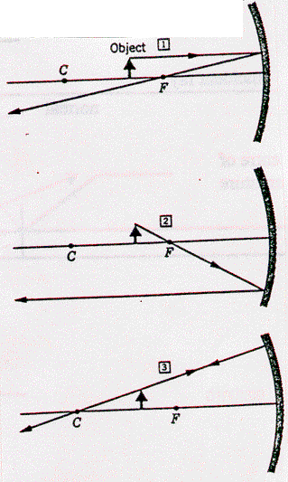formed. *The point where the three rays cross is the location of the image*.

Ray 1 The incident ray which is parallel to the principal axis will reflect through (or away from) the focal point.

Ray 2 The incident ray through the focal point is reflected parallel to the principal axis.

Ray 3 The incident ray travels along a line that passes through the centre of curvature and reflects straight back.

Whether or not an image is formed depends on a number of factors

1. type of mirror (concave or convex)
2. the focal length (f)
3. the distance from the mirror to the object (do)

The following are the six cases for drawing ray diagrams. They are supplied here for your reference.

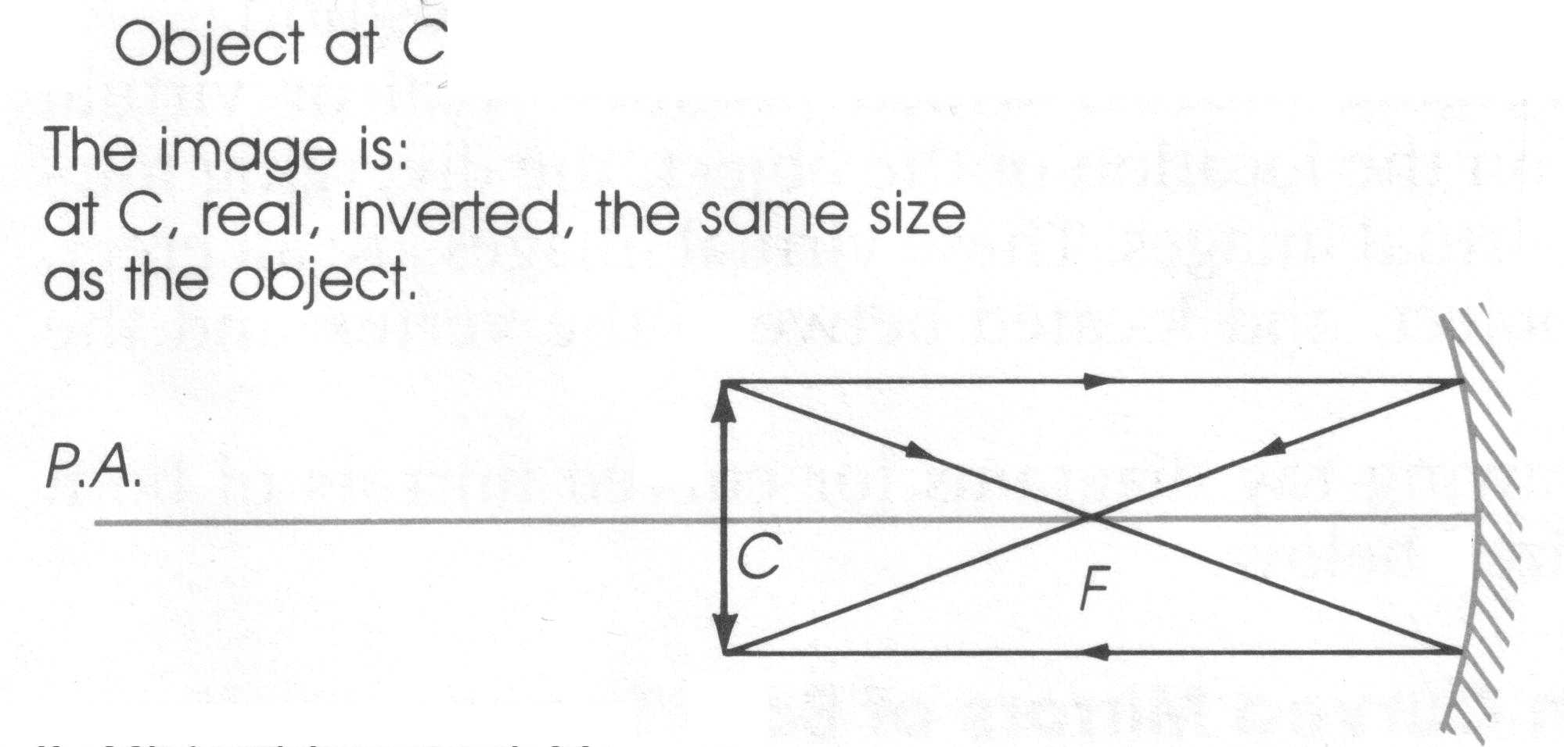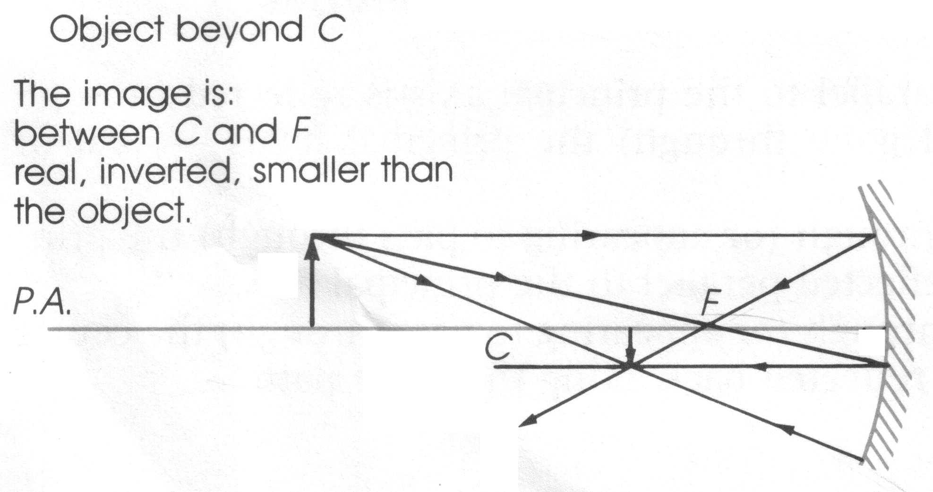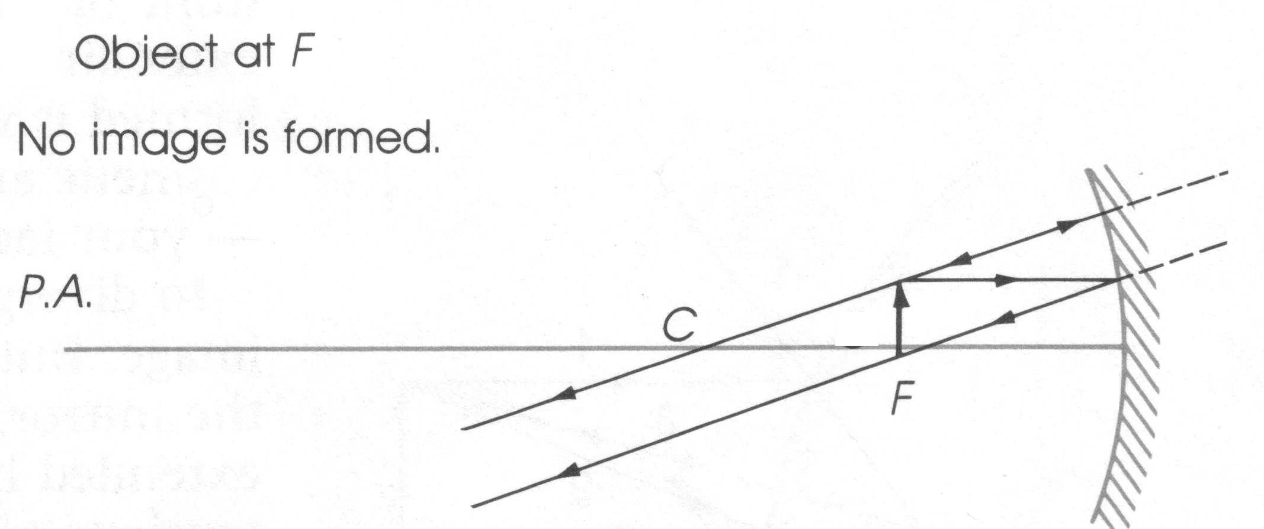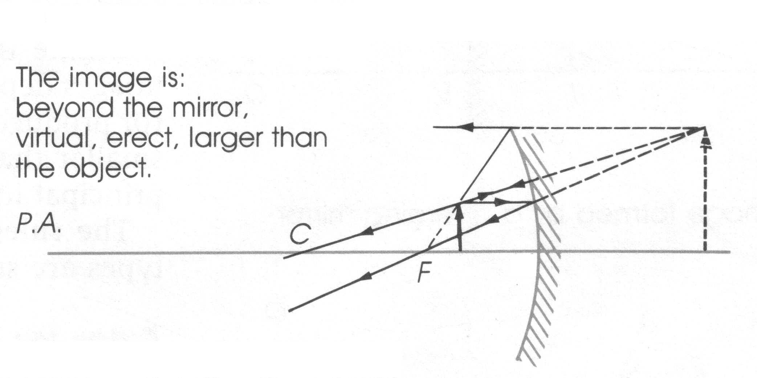

Object between F and the mirror

object

image

object

object

image

image

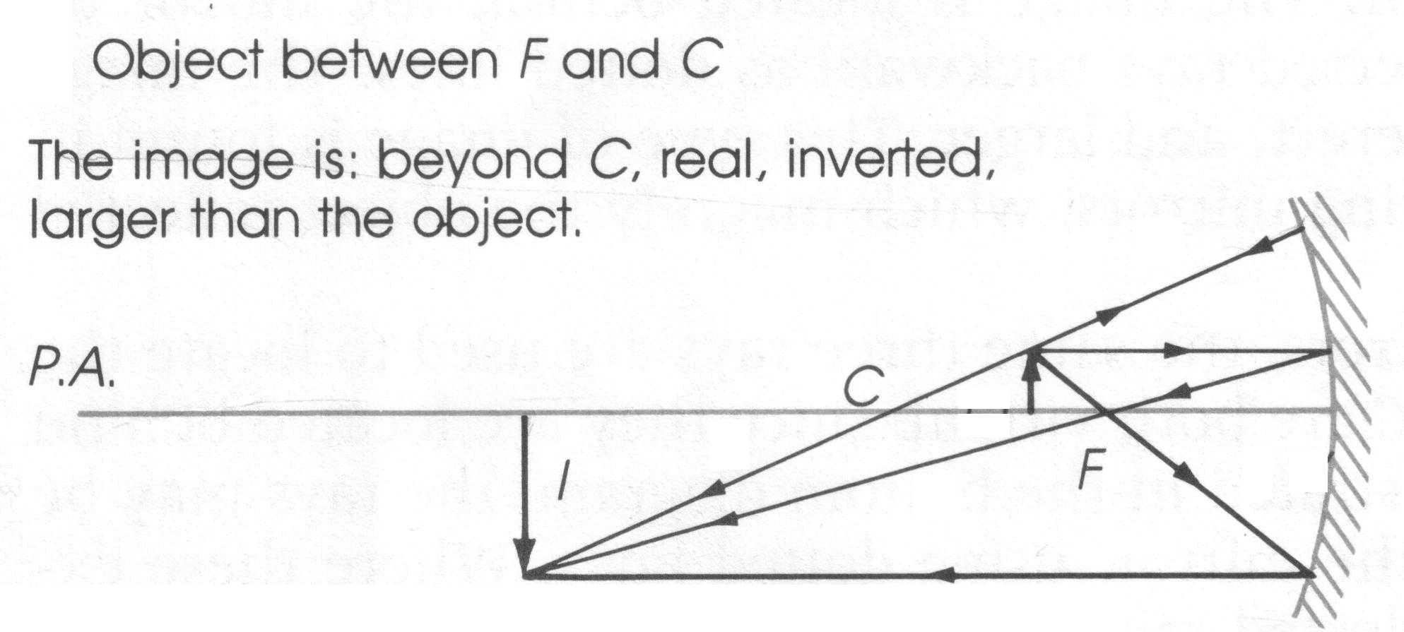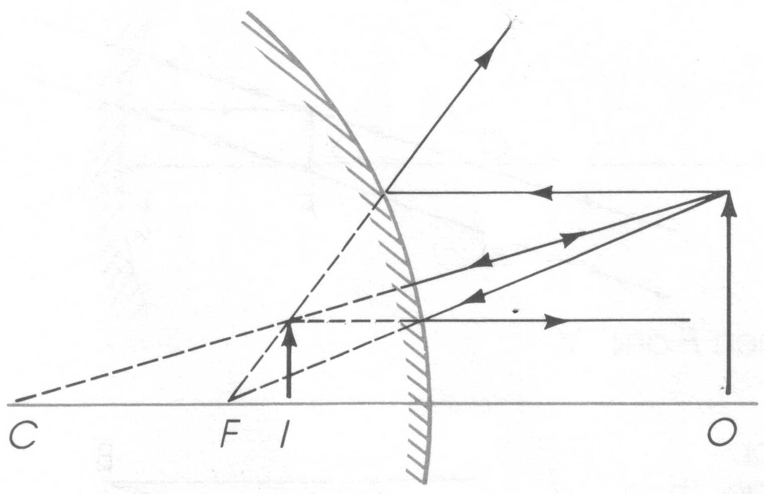

Diverging mirror

object

object

image

image

*Examples*:

Note: These examples will be done as part of a lecture class.

Object beyond C

•

•

principal axis

C

f

Object at C

•

•

principal axis

C

f

Object between f and C

•

•

principal axis

C

f

Object at f

•

•

principal axis

C

f

Object inside f

•

•

principal axis

C

f

Object and convex mirror

•

•

f ’

principal axis

C’

# Mirror equations

The following mirror equations are very useful:

where

*R* radius of curvature of the mirror

*f* focal length

*do* distance from mirror to the object

*di* distance from the mirror to the image

*ho* height of object

*hi* height of image

*M* magnification



As we saw above, real images exist in real space and are always inverted, while virtual images exist as images “within” the mirror and are always erect. In order to use the equations properly it is necessary to have the proper signs for each variable. The proper signs for each kind of image, object and mirror is given below.

*Virtual image*

1. di is negative
2. always erect

*Real image*

1. di is positive
2. always inverted

*f* (+) for concave mirror

(-) for convex mirror

*do* always (+)

*di* (+) for a real image

(-) for a virtual image

*ho* always (+)

*hi* (+) for a virtual image

(-) for a real image

A 5.0 cm tall object is placed 60 cm away from a converging mirror that has an 80 cm radius of curvature. Describe the image formed.

ho = 5.0 cm





 = **+120 cm**



= **– 10 cm**

do = 60 cm

R = 80 cm



converging

mirror

The (+) di means that the image is **real** and **inverted**. (All real images are inverted.)

The image is 10 cm tall, i.e. larger than the object.

A 5.0 cm tall object is placed 60 cm away from a diverging mirror that has an 80 cm radius of curvature. Describe the image formed.

ho = 5.0 cm





 = **–24 cm**



= **+ 2 cm**

do = 60 cm

R = 80 cm



diverging

mirror

The (–) di means that the image is **virtual** and **erect**. (All virtual images are erect.)

The image is 2 cm tall, i.e. diminished.

The erect image of an object is one-third the size of the object. If the object is 20 cm from the mirror, what kind of mirror is it and what is the focal length?

The image is erect (i.e. virtual) and smaller (i.e. di is less than do). The only way this can happen is with a **convex** (diverging) mirror. (A virtual image is always larger for a concave (converging) mirror and is always smaller for a convex (diverging) mirror.)



= -0.10

 = **– 10 cm**

di is (–) for an erect image

= -6.67 cm

# Practice problems

1. An object which is 5 cm tall is placed 14 cm in front of a concave mirror which has a radius of 10 cm.

A. What is the image distance. (7.8 cm)

B. Describe the image. (real, inverted, smaller)

C. What is the size of the image? (-2.8 cm)

2. An object which is 5 cm tall is placed 14 cm in front of a convex mirror which has a radius of 10 cm.

A. What is the image distance. (-3.68 cm)

B. Describe the image. (virtual, erect, smaller)

C. What is the size of the image? (1.32 cm)

3. The inverted image of an object is a quarter the size of the object. If the object is 30 cm from the mirror:

A. What kind of mirror is it? (concave)

B. What is the focal length of the mirror? (6.0 cm)

# Hand-in assignment

1. Draw ray diagrams for the following situations. Locate and describe the image.

A. (virtual, erect, smaller)

principal axis

• •

f C

B. (virtual, erect, larger)

principal axis

• •

C f

C. (no image forms)

principal axis

• •

C f

D. (real, inverted, larger)

principal axis

• •

C f

E. (real, inverted, smaller)

principal axis

• •

C f

F. (real, inverted, same size)

• •

C f

principal axis

2. A 6.0 cm tall object is placed 40 cm in front of a concave mirror with a radius of curvature of 60 cm.

A. What is the image distance? (120 cm)

B. What is the size of image produced? (-18 cm)

C. Describe the image. (inverted, real, larger)

3. A 6.0 cm tall object is placed 40 cm in front of a convex mirror with a radius of curvature of 60 cm.

A. What is the image distance? (-17 cm)

B. What is the size of image produced? (2.6 cm)

C. Describe the image. (erect, virtual, smaller)

4. An object located 40 cm in front of a mirror produces an erect image 80 cm from the mirror.

A. What is the radius of curvature for the mirror? (160 cm)

B. What type of mirror is it? (concave)

5. An object located 40 cm in front of a mirror produces an inverted image 120 cm from the mirror.

A. What is the radius of curvature for the mirror? (60 cm)

B. What type of mirror is it? (concave)

6. An object located 40 cm in front of a mirror produces an erect image 20 cm from the mirror.

A. What is the radius of curvature for the mirror? (-80 cm)

B. What type of mirror is it? (convex)

7. A 20 cm object located 30 cm in front of a mirror generates an erect image that is 10 cm tall. What is the size of image produced when the object is moved 60 cm further from the mirror’s surface? (5.0 cm)

8. An object located in front of a concave mirror with a radius of curvature of 80 cm produced an inverted image that is three times the size of the object. What is the object distance? (53 cm)

9. An object located in front of a concave mirror with a radius of curvature of 180 cm produced an erect image that is two times the size of the object. What is the object distance? (45 cm)

10. An object located in front of a convex mirror with a focal length of 60 cm produced an erect image that is 1/6 the size of the object. What is the object distance?

(300 cm)

Activity – Concave Mirrors

**Purpose**:

To determine the focal length of a concave mirror.

**Apparatus**:

Set up your own apparatus based on the diagram below. Be sure to return all materials to their appropriate places after you have completed the lab.

do

light source

mirror

meter stick

90

80

70

60

50

30

20

10

stand

**Theory**:

The mirror equation is: 

Therefore, if we measure the object distance and the image distance we can determine the focal length of the mirror.

**Procedure**:

1. Place the object at some point in front of the concave mirror. (Start at around 60 cm.) Record the object distance (distance from mirror to object).

2. Using a white piece of paper as a screen, move the screen until a sharp image of the object (the bulb filament) appears on the screen. Record the image distance (distance from mirror to the screen).

3. Repeat steps one and two until a total of three different positions have been located.

**Observations**:

Create an appropriate data table to organise your results.

**Analysis**:

1. Calculate the focal length for each position and then find an average result. Show all work and calculations.

2. Draw scale ray diagrams for each position showing the formation of each image.